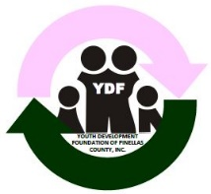

YDF of Pinellas Community, Inc.

Board Meeting

Fundraising Report

03.02.2020

**Save The Date:**

* Harlem Nights – June 20, 2020 – The Manhattan Casino
* Alpha Omega Holiday Party – Friday, December 11, 2020 – The Coliseum
* Debutante Cotillion - March 20, 2021 – The Coliseum

**Harlem Nights:**

* Manhattan Casino 9 – Midnight;
* Silent Auction;
* Gambling (entertainment purposes only) – DanMar Productions;
* Costume Contest – survey suggestion; and
* Cigar Bar – survey suggestion(to be confirmed).

**2020 Holiday Party Update:**

* Holiday Party Planning Committee meets the first Tuesday of each month at 6:30 pm at Enoch Davis Center; and
* Committee is revamping the party due to reduced attendance.
  + Suggestions include:
    - Live entertainment
    - VIP Ticket
    - Cigar Bar
    - Photo Booth instead of Photographer

**Debutante Cotillion 2021:**

Sponsorship package has been developed; and

Potential sponsors are being identified.

**Respectfully Submitted:**

Rita Wesley, Community Liaison