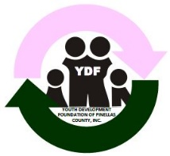

YDF of Pinellas County, Inc.

Community Liaison Report

Board Meeting 03.01.2020

The YDF President has a monthly standing meeting scheduled with the Community Liaison to discuss progress, goals, deadlines, etc.

Goals for 2020 include:

* Developing a comprehensive sponsorship package for all fundraisers;
* Presenting a minimum to two new funding opportunities to the YDF President for consideration;
* Developing a marketing and communications strategy; and
* Hosting an annual Friendraiser.

**March Funding Opportunities – pending YDF President Approval:**

1. Tampa Bay Professional Sports Teams – request for items for Silent Auction for Harlem Night scheduled for Saturday, June 20, 200 will be submitted in March 2020.
2. Harlem Nights Fundraiser Sponsors – Sponsor Letters will be mailed by the first week of March to previous event sponsors.

**First Quarter Goals**

1. Create excel spreadsheet of current/former sponsors
2. Clean up current sponsor mailing list
3. Create sponsorship package for specific events/all events
   1. Harlem Nights Sponsorship Package is complete pending YDF President approval.
   2. 2021 Debutante Cotillion Package is complete pending YDF President approval.
4. Create excel spreadsheet of all voucher requests related to fundraisers
5. Create a Grant Matrix for fundraising opportunities

**Upcoming Board Meetings**:

1. June
2. August – Budget Meeting
3. November

**Respectfully Submitted:** Rita Wesley, Community Liaison