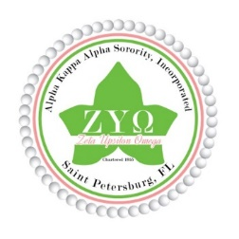Alpha Kappa Alpha Sorority, Inc. 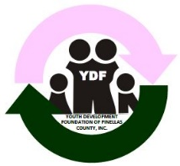

Zeta Upsilon Omega Chapter

YDF of Pinellas County, Inc. ~ 2nd Anti-Basileus Report

YDF Annual Meeting Report 09.14.2020

**Save the Date:** Alpha Omega Holiday Party – December 11, 2020

Debutante Scholarship Cotillion – March 20, 2021

**Alpha Omega Holiday Party Committee (AOHP):** recommended the AOHP 2020 be hosted virtually on Friday, December 11th via ZOOM/Twitch. Tickets priced at $20 each. The Fundraising Committee will provide more information and a recommendation.

**Fundraising Committee Action:** The Fundraising Committee hosted an internal chapter fundraiser with a goal of $2000.00. **Total Amount Raised** as reported by the Finance Committee is $936.80. The Fundraising Committee will provide any additional information if necessary.

**St. Pete Police Department Forfeiture Fund:**

A request for $2k for a Human Trafficking & Safety Awareness Project for Women and Girls ages 16 to 92. The project can be done virtually. Award announcement is mid October 2020.

Amazon Smile link for YDF will be submitted for the Eblast, <https://smile.amazon.com/ch/91-2002544>

During the summer break, I’ve actively engaged in Assessment Task Force

meetings. Assessment Task Force Chairman Manitia Moultrie will provide more information.

**Respectfully Submitted:**

Rita Wesley, 2nd Anti Basileus ~ Community Liaison